**A novel scoring system based on molecular gene signatures of stromal heterogeneity for Triple-negative breast cancer (TNBC)**

*Varun Ullanat (varunullanat.bt17@rvce.edu.in)*

**1. Introduction**

Triple-negative breast cancer (TNBC) is a type of breast cancer that tests negative for oestrogen receptors, progesterone receptors and excess HER2 protein. TNBC accounts for about 10-15% of all breast cancers and is commonly seen in women younger than 40. It is generally treated with chemotherapy, surgery or a combination of both. Identifying subsets of TNBC patients who have very adverse features for more aggressive therapy could help in improving patient outcomes.

The stroma is a heterogeneous population of cells consisting of the tumour bulk plus supporting cells. These supporting cells are recruited by cancer cells from nearby endogenous host stroma and promote events such as tumour angiogenesis, proliferation, invasion, and metastasis, as well as mediate mechanisms of therapeutic resistance. Stromal heterogeneity has not been well characterized despite the key role that it may play in tumour progression.

Here, I propose a novel scoring system for TNBC based on the stroma of the tumour. The scoring method is based on expression data (microarray/RNA-seq) from TNBC stromal samples. Four features of the stroma are taken into consideration, namely T-cells (T), B-cells (B), stromal infiltrating epithelial cells (E), and desmoplasia (D). The demo is done for the Mainz dataset, published by Schmidt et al. (2008). All programming was done using R.

**2. Proposed scoring method**

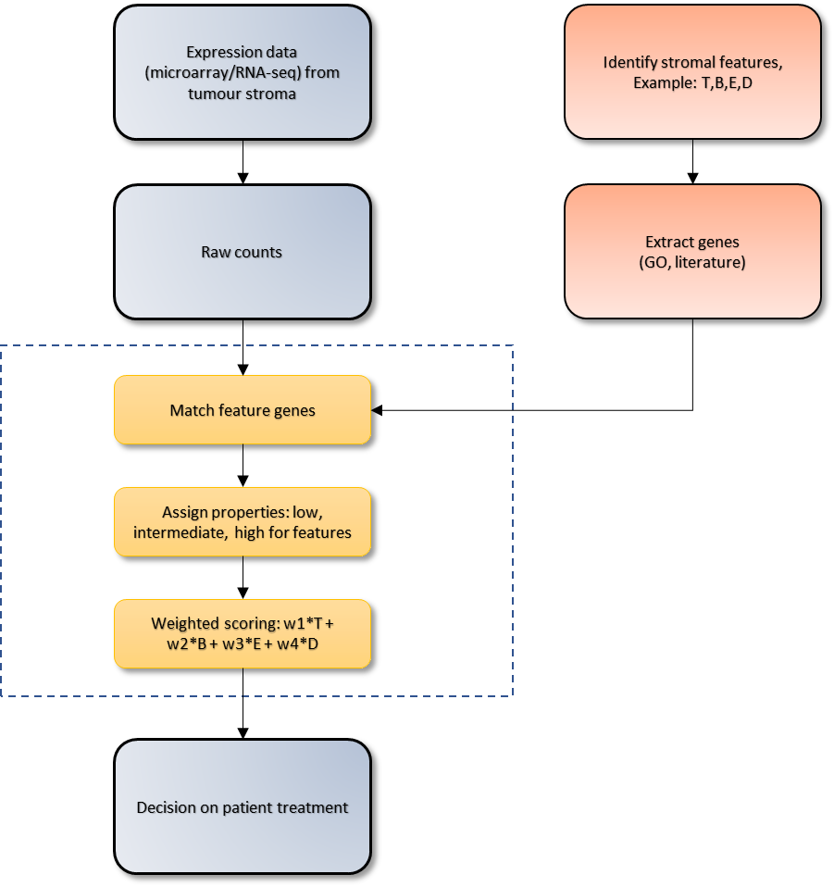

**3. Results**

**3.1 Stromal features**

|  |  |  |  |  |
| --- | --- | --- | --- | --- |
| S.No | Feature | Symbol | Number of genes identified | Genes (First 5) |
| 1 | T-cells | T | 458 | WASL, RAI14, TTC3, TNKS, GPR32 |
| 2 | B-cells | B | 567 | IGLL5, CPNE5, PSPN, BF175071,  SCAMP4 |
| 3 | Stromal infiltrating epithelial cells | E | 27 | CTNND1, MT1F, MT1B, MT1L, MT1A |
| 4 | Desmoplasia | D | 297 | CCAR1, GPT2, UTP3, DUSP12, FBXO5 |

**3.2 Number of matched genes for Mainz dataset**

|  |  |  |
| --- | --- | --- |
| S.No | Feature | Number of matched genes |
| 1 | T-cells | 104/567 |
| 2 | B-cells | 315/458 |
| 3 | Stromal infiltrating epithelial cells | 20/27 |
| 4 | Desmoplasia | 104/297 |

**3.3 Scoring for Mainz dataset**

|  |  |  |
| --- | --- | --- |
| S.No | Property | Score |
| 1 | Low | 0 |
| 2 | Intermediate | 0.5 |
| 3 | High | 1 |

Total score is given by:

$Score= ∑\left(weight\right)$*(Propertyi)(Featurej) for i = 1:3, j = 1:4*

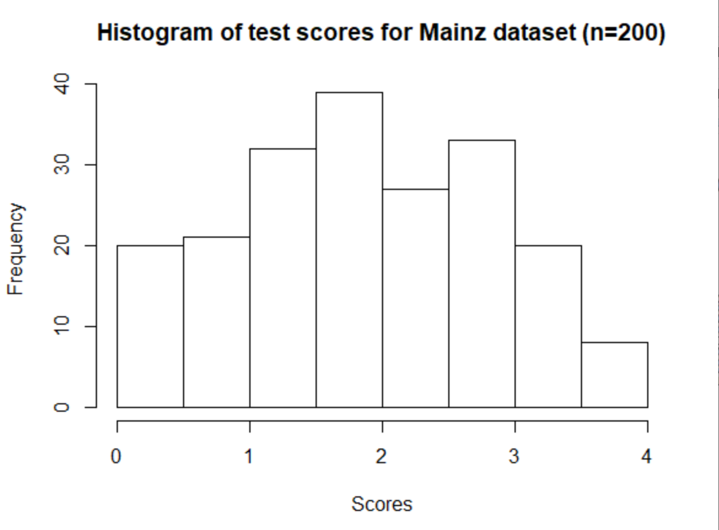

**3.4 Patient outcome**

Finally, a decision can be made for the patient depending based on the score.

|  |  |  |
| --- | --- | --- |
| Score | Severity | Suggested treatment |
| <1.5 | Low risk | Surgery |
| 1.5-3 | Intermediate risk | Neoadjuvant chemotherapy followed by surgery |
| >3 | High risk | Chemotherapy with platinum drugs |